The Piggyback Foundation of Youngstown
Impact Report: 2018

Janelle Nagy, Director
piggybackyoungstown@gmail.com 248-200-8032 www.piggybackyoungstown.com

“The Piggyback Foundation provides those little extras that easily get overlooked, yet mean so much”
-- 33 year old breast cancer patient and mother of two
Table of Contents
Mission & History Page 1
Impact Page 2
Finance – Fundraising Page 3
Finance – Expenses /Community Investment Page 4
The Future: 2017 & Beyond Page 5
Piggyback Operations & Board of Directors Page 6

Contents

Mission
While there are many physical, emotional, and financial assistance programs available to help the patient battling life-threatening illness, children and families can suffer some unintended consequences. Grades drop when there’s less time for homework help; medical bills must get paid before there’s money for extra-curricular activities, and family togetherness is reduced to frazzled drives between doctor appointments. The Piggyback Foundation of Youngstown provides funding and opportunity to improve family quality of life during times of incredible stress – particularly for children.
Programs include:
School Counts: Provides funding and access to academic tutoring and school supplies, as needed. Thus far, Piggyback has provided $3,985 worth of goods and services through its School Counts program.
Kids Count: Provides funding to enroll in or continue extra-curricular activities. Piggyback provides not only for enrollment fees, but also all necessary equipment, supplies, etc. In 2018, Piggyback has provided $1,208 worth of service through its School Counts program.
page 1 Mission & History
“While there are many physical, emotional, and financial assistance programs to help the patient...
children and families can suffer some unintended consequences…”
Piggyback is here to help.
Family Counts: Provides funding and coordination to support family togetherness. It’s amazing how a family movie night or bowling excursion can help everyone forget their stress – even if just for a little while. Piggyback also helps with holiday and birthday celebrations. Since January of this year, PBF has $10,825 worth of fun for Youngstown families!
History
The Piggyback Foundation started in Norwalk, Ohio, and still thrives there today. The mission was brought to the Youngstown community when a former Norwalk Board Member moved to Canfield. Piggyback Youngstown held its inaugural fundraiser, a Chocolate Fest, in May 2016. Since then, Piggyback Youngstown has poured over $45,000 worth of goods and services into the community. Piggyback has adopted 10 families since its 2016 inception; serving 26 children and their parents/grandparents!

Impact
These are just a few of the goods and services Piggyback Foundation has provided to its adopted families during 2018:
“We have no way of taking a vacation together; now I have something to look forward to this summer !”
--A mother of 2 teenage boys, who enjoyed a long weekend at Cedar Point with her family. She battles ALS but conquered *all* of the rollercoasters!
page 2 Impact
A limo celebration, PBF Christmas party, a child enrolled in baseball, guitar lessons for a young Rockstar, Boardman Swim Club membership, a Cedar Point weekend, Disney fun!, YMCA memberships for all, and a cancer-free celebration at a trampoline park

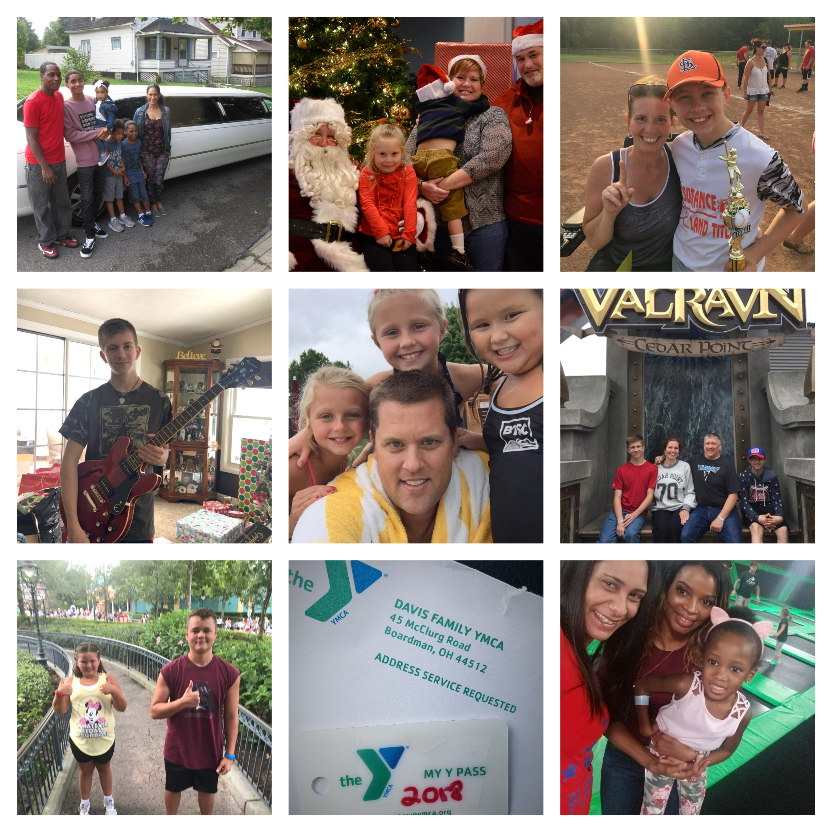
- An all-expense-paid weekend trip to Cedar Point for a family of 4
- Enrollment in guitar lessons, school band, football, soccer, and cheerleading plus all required equipment
- Various live theatre experiences for children to enjoy: STOMP, Cavs, local bands, etc.
- Admission, full day ride passes, and concessions money to the Canfield Fair
- Grocery gift cards to cover the cost of both Thanksgiving and Christmas meals
- A plethora of donated Christmas gifts for all family members
- Funding for a gifted student to attend YSU’s Summer Honors Institute
- A limo ride to celebrate the end of chemo for a 8 year old who beat cancer! Plus a party for 50 of his loved ones
- A fully loaded Chromebook for a 7 year old student who battles leukemia
- Ongoing private tutoring for a sick child. He maintains straight A’s.
- School supplies for all 18 children; including $100 gift cards for personal items like shoes and backpacks
- Annual YMCA family memberships for all PBF families
- Various gift cards for family fun: movies, bowling, Chuck E Cheese, Boardman swim club, etc.
- $500 Contribution toward a family’s Disney trip
The Chocolate Fest has become Piggyback’s signature fundraiser, raising over $6,500 in 2018!
\

Fundraising
The Piggyback Foundation of Youngstown is entirely run by volunteer power. There are no expenses for employees or overhead, because all of the work is conducted from the home office of its Director.
As a fledgling nonprofit, almost every dollar we raise is through grassroots efforts: event attendance, sponsorship, online giving campaigns, etc. We were blessed with a few grants in 2018, and they made a huge impact on our families! Below are descriptions of our major fundraising efforts:
Chocolate Fest: The Chocolate Fest is Piggyback’s signature fundraiser. This event showcases chocolate desserts from many restaurants, bakeries, and grocery stores in the Mahoning Valley. Every cake, pie, cookie, brownie, and truffle is donated. Naturally, we also have a basket auction and a 50/50 raffle. This event has grown to 4x its size! In 2018, it hosted 225 guests and made over $6,500! In 2019, we anticipate 300 guests and are hoping to near $8,000.
Physicians Supper Club: A private group of local physicians asked Piggyback to form a charity supper club. PBF volunteers organize a special Chef’s Dinner once each season and the doctors enjoy a night out together with good cause. This new project netted about $3,000 in 2018 but has plans to grow in 2019.
Summer Bash: Piggyback is one of three charitable recipients of a party put on by the Youngstown medical community. Dr. Manuel Bautista plans a July birthday party with live bands, auction, salsa dancing, etc. and invites all of his many friends. This event made a total of $6,000 in July 2018. Excited by its success, Dr. Bautista wants to reach $10,000 in 2019.
Bingo For Baskets: Designer Purse Bingo is the hot fundraiser trend right now. Piggyback jumped right on the bandwagon and hosted a Bingo event in Fall of 2018. Local newscaster Dave Sess called Bingo to a sold out crowd of 135. We were able to raise over $4,600 which offsets the costs of all holiday meals, gifts, and special events for our Piggyback families. Like our Chocolate Fest, we completely sold out the event space and intend to move to a larger venue in 2019.
Grants: This year, Piggyback was the recipient of a $2,500 grant from the Centofanti Foundation, which enabled us to adopt a new family in January! This family has been extra special to us because they are so much fun! Their two teenage boys took up guitar and baseball with the help of PBF, and both excel at their interests! We were thrilled to send the family to Cedar Point for a weekend, and Mom said the school supply help was a “life saver” at a rough time. Because of a Community Foundation grant for $1,500 and the cooperation of the YMCA, we were able to provide all of our PBF families with YMCA annual memberships!

page 3 Finance
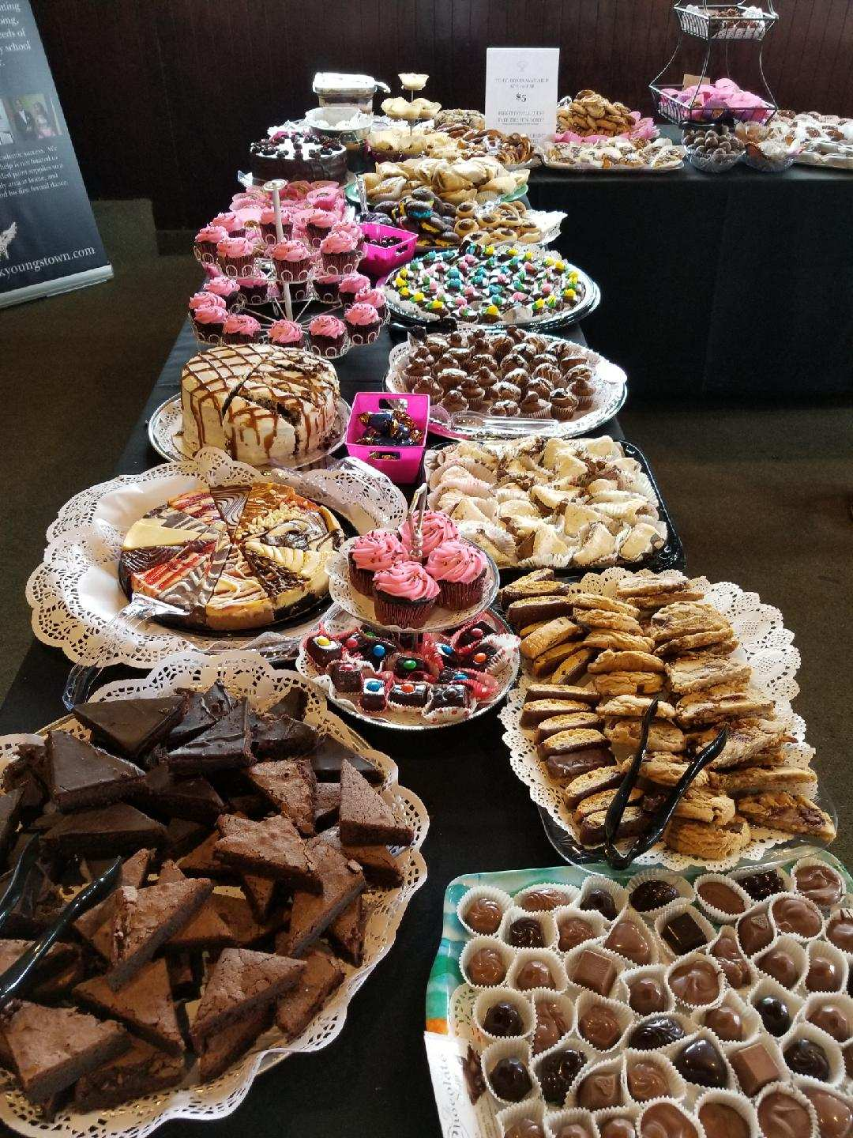

Monetary Investment: $15,843
In-Kind Donations $12,200
Total Invested in Community 2018:
$28,043!
Monetary Investment
$10,125 “Family Counts” Program
$4,020 “School Counts” Program
$1,358 “Kids Count” Program
$100 Emergency Funding provided to families in crisis
$140 Birthday Gift Cards
$100 Akron Children’s Hospital Christmas Party
$15,843 Total Monetary Expenditures
In-Kind Donation Values
$7,000 Christmas Gift Donations – 25+ buyers!
$500 Donated value of Cedar Point tickets
$950 Donated value of Limo celebration
$500 Activity donations: bowling, trampoline park, etc.
$3,250 YMCA membership discount
$1,000 Administrative supplies - donated
$11,200 Total In-Kind Donation Value

Piggyback “adopts” families for at least a full year. This model allows us to be “at the ready” when crisis hits. Stress is reduced before it even begins because our families know they can lean on us. In the above photo are take-out gift cards to local restaurants. These were proactively bought by a family liaison when PBF learned one of our adopted Moms had an unexpected week in the hospital. We don’t know who was more relieved: Dad, who got take out for him and the boys; or Mom, who, from her hospital bed, was worried about her family’s meals.
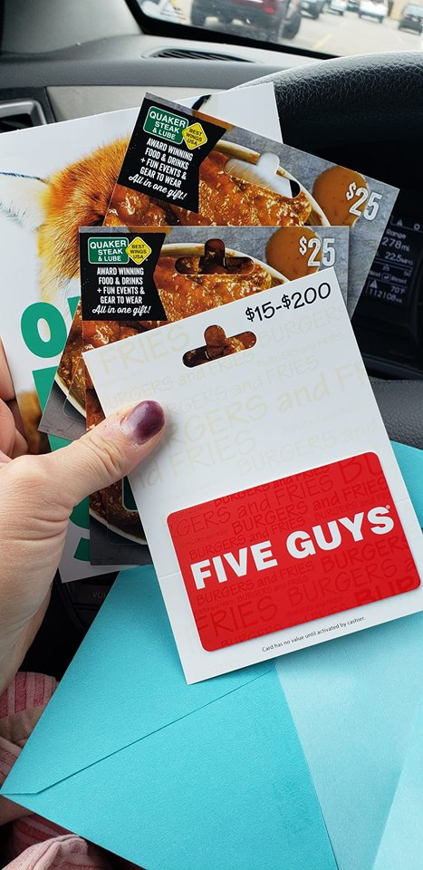
Community Investment
Piggyback is founded on the premise that a life-threatening illness affects not only the patient – but the whole family. Togetherness, hobbies, and academic support are of utmost importance during a health crisis. In an effort to support normalcy and stress relief – especially for children -- here are the investments Piggyback has made in the community this year:
\
page 4 Finance
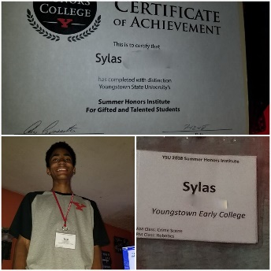
Sylas is the older brother of a PBF child who battles cancer. Sylas is extremely gifted and plans to become an architect.
Sylas’ mother works tirelessly to ensure that her ill child becomes well, *and* that her gifted child is academically challenged.
Inspired by her hard work and determination, Piggyback has partnered with Akron Children’s Hospital to offer a college and career preparedness program, beginning in July, 2019.
2018 & Beyond
Piggyback has recruited and maintained a dedicated Board of Directors, along with several reliable volunteers who love the cause.
Because of our plethora of volunteers, we have recently initiated outreach that will allow our mission to impact the community in new ways.
Partnership with Akron Children’s Hospital & Inspiring Minds
Piggyback Youngstown was approached by Dr. Daniel Pettee of Akron Children’s Hospital Beeghly Campus to provide college and career readiness for patients in the Adolescent and Young Adult Cancer Program. Piggyback* will coordinate with Inspiring Minds Youngstown to offer these services to Akron Children’s young adult patients battling cancer and blood disorders:
College Application & Essay Writing Workshops: Two workshops per year, on ACH Beeghly campus. Each workshop will require three separate meetings for crafting and editing essays. Inspiring Minds professionals will provide insight to appropriate college programs, written application tips, and essay composition.
FAFSA Navigation Workshops: Two workshops per year, on ACH Beeghly campus. Each workshop will entail pre- and post- meeting discussion between financial aid specialists and parents. This workshop will give instruction about how to file FAFSA using the most pertinent financial information, the FAFSA application process, and timeline. Inspiring Minds will also research scholarship and grant opportunities for each individual student.
College Campus Visits and Job Shadowing: Piggyback volunteers will coordinate college campus visits and job shadowing opportunities for all interested patients. These may be local colleges, or long distance.
*Piggyback’s role will mainly be the aforementioned campus visits and job shadowing coordination, along with securing of all necessary funds to execute this program.

page 5 The Future

Piggyback Operations
In order for families to partake in the programs offered by The Piggyback Foundation of Youngstown, an application must be completed. The process requires at least one child under the age of 18 reside in the home, and a signed doctor’s note confirming life-threatening illness is submitted. The illness can affect a child, parent, or grandparent who lives in the home; it need not be terminal, but must be life-threatening. The application process does not require demonstrated financial need – as illness strikes all walks of life. Applicants must live within an approximate 25 mile radius of Youngstown. Applications are reviewed by the Board of Directors and accepted based on the charity’s ability to maintain family aid for a full calendar year.
Currently, Piggyback has five adopted families. There are 18 children among the families. Collectively, they battle stage four cancer, ALS, Crohn’s Disease, and childhood leukemia. Children range in age from 1 year months to 18. Most of the families live at or just above the poverty line.
The Piggyback Foundation of Youngstown’s volunteer Board of Directors includes:
Janelle Nagy – Director
Debbie Strickland – Retired
Jane Witt – Retired
Leann Rich – Mahoning Valley Historical Society
Lisa Miller – YMCA of Youngstown
Lori Bisconti – Bisconti Orthodontics
Angela Douglass – Kent State University Nursing
Erica Smith - Mercy Health Boardman
Tina Serra – Accountant
Sam Fries – SSB CPA’s
Kimberly Ilgenfritz – OnX Enterprise Solutions
Amanda McCormick – Mercy Health Boardman
Sarah Heinn – Akron Children’s Hospital
Tanisha Wheeler – Inspiring Minds Youngstown
More information can be found by visiting the Piggyback Foundation of Youngstown’s website: www.piggybackyoungstown.com or find us on Facebook for the latest updates.

Piggyback Foundation of Youngstown
PO BOX 3184
Boardman, OH 44513
Web:
www.piggybackyoungstown.com
Phone:
248-200-8032 (cell)
Email:
piggybackyoungstown@
gmail.com

page 6 About

